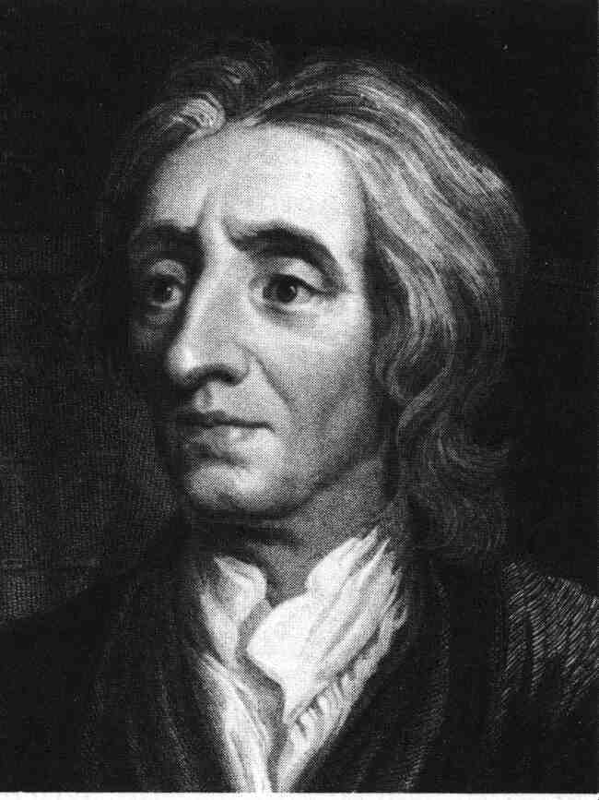

The Enlightenment
A Reaction to Absolutism

- Baroque- Relating to a grand, ornate style that characterized European painting, music, and architecture in the 1600s and early 1700s.
- Checks and Balances- Measures designed to prevent any one branch of government from dominating the others.
- Constitutional Monarchy- A system of governing in which the ruler’s power is limited by law.
- Enlightened Despot- One of the 18th century European monarchs who were inspired by Enlightenment ideas to rule justly and respect the rights of subjects.
- Free Market- An economy based on supply and demand, with little or no government regulation.
- General Will- Made famous by Rousseau; the political philosophy referring to the will of the people as a whole.
- Laissez faire- The idea that government should not interfere with or regulate industries and businesses.
- Natural Laws- The use of reason to analyze human nature.
- Natural Rights- According to Locke, rights that all humans are born with: life, liberty, and the right to own property.
- Philosophe- One of a group of social thinkers in France during the Enlightenment.
- Prime Minister- The executive branch of government in a parliamentary system.
- Salon- A social gathering of intellectuals and artists, like those held in the homes of wealthy women in Paris and other European cities during the Enlightenment.
- Separation of Powers- Under this model, the state is divided into branches, each with separate and independent powers and areas of responsibility so that no branch has more power than the other branches. The normal division of branches is into a legislature, an executive, and a judiciary.
- Social Contract- The agreement by which people define and limit their individual rights, thus creating an organized society or government.
- The Wealth of Nations- In his book the Wealth of Nations, Smith argued that if individuals freely followed their own self-interest, the world would be an orderly and progressive place. The Wealth of Nations defends the idea of a free market economy, where economic liberty guaranteed economic progress. Government should not interfere in the economy.
Philosophers of the Enlightenment
Adam Smith Baron de Montesquieu
Jean-Jacques Rousseau John Locke
Thomas Hobbes Voltaire

